English Vocabulary – Cooking Methods

grilled fillet of fish  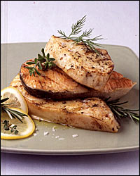 | roast potatoes  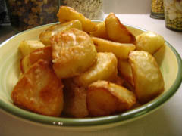 | sautéed potatoes  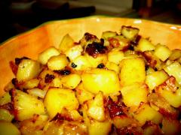
seared swordfish  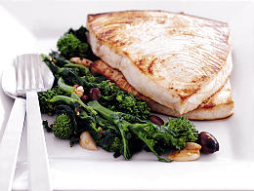 | fried cod  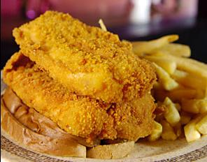 | boiled eggs  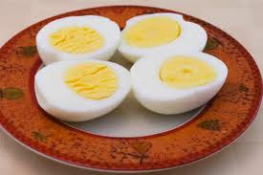
toasted bread (toast)  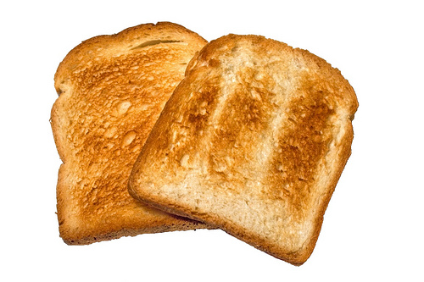 | baked potato  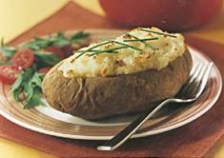 | sun-dried meat  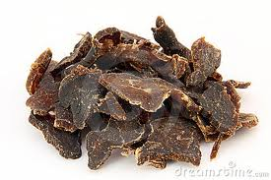
braised mushrooms  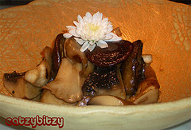 | mashed potatoes/mash  (potato purée)  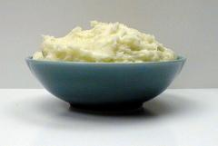 | steamed vegetables  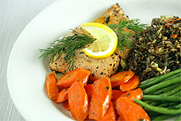
poached egg  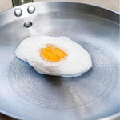 | scrambled eggs  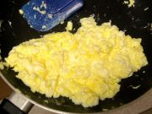 | 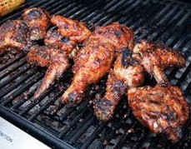  barbecued chicken

to grill ________________ to roast ________________
to sauté ________________ to sear ________________
to fry ________________ to boil ________________
to toast ________________ to bake ________________
to sun-dry ________________ to braise ________________
to mash ________________ to steam ________________
to poach ________________ to scramble ________________
to barbecue ________________
Other verbs:
to chop ____________________________
to marinade ____________________________
to smoke ____________________________
to slice ____________________________
to peel ____________________________
to cut ____________________________
to dice ____________________________
to mince ____________________________
to halve ____________________________
to rinse ____________________________
to lift out ____________________________
to cook ____________________________
to put in/add ____________________________
to drain ____________________________
to mix ____________________________
to stir ____________________________
to toss / flip ____________________________
to dip ____________________________
to squeeze ____________________________
to fill up ____________________________
to pour ____________________________
to set ____________________________

